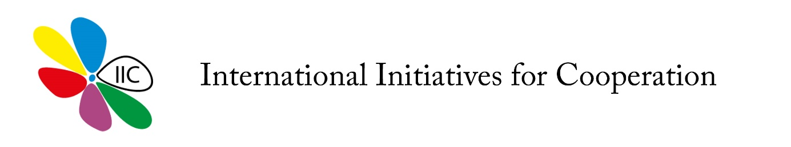
APPLICATION FORM FOR PARTICIPANTS

Erasmus+ KA1 Youth exchange
16-22.10.2017 - “We NEET to activate!”
Please, fill in and send it to us by email the latest on 30. of September.
Participants should:
- Be 18 – 25 years old
- Be motivated to participate in the project
- Be able to communicate in English
- Respect the program rules, schedule and activities, participating in the entire project

IMPORTANT: All participants must be on time to all sessions, respecting all the program of the exchange which will be sent before its implementation. Moreover, we emphasize that this is NOT a tourist stay or a vacation, and the participants must be motivated and interested in the theme.
Name : | Last name :
Country : | Date of Birth :
Gender (M/F) : | Nationality :
Your E-mail : | Phone number :
ENGLISH LEVEL  Poor, Good, Very Good | Mobile number :
Health and alimentation conditions (vegetarian, vegan, food intolerances, etc.)
Please explain if you have any allergies or other food intolerances. Specify to what food or ingredients you have reaction or you simply do not eat.

Motivation
What is your motivation to take part in the project in one sentence?
What can you offer to the project?
Describe in couple of sentences what can you offer to the project and its participants.

Follow-up
What kind of activities are you willing to organize back in your country to disseminate the project results. Please describe how you plan to organize them, what kind of stakeholders you will involve and what kind of support you can get.

THANK YOU AND WE LOOK FORWARD TO MEETING YOU!!!

